You have probably come across the abbreviation API. It can be seen almost anywhere: in software, Internet protocols, websites. The API is used by many services and applications. In this topic, we will find out what it is, what it is for, and how it makes life easier for the developers.

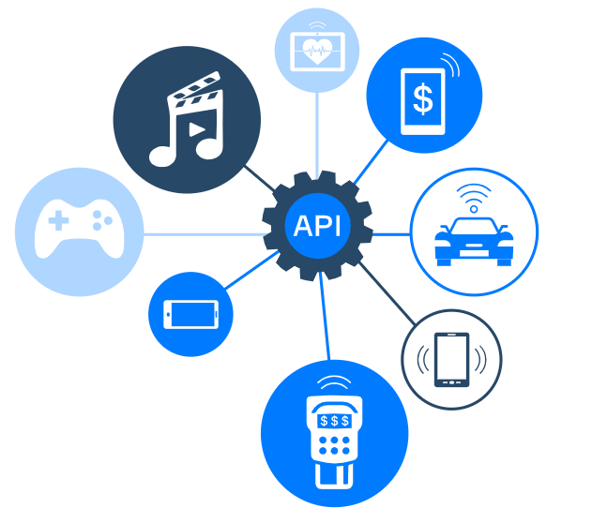

**What is API**

**API** stands for **Application Programming Interface**.

Usually, when we say interface, we mean a user interface that connects a computer to a user. However, in this case, we are talking about the connection of a computer or a piece of software with another. This also needs some kind of interface, i.e. API.

API is a description of the ways and rules by which different programs can interact with each other. The basic principle of the API is that programs have certain functions, classes, methods, structures, and sometimes constants that can be accessed by other programs using the corresponding interface.

It is not intended to be used directly by the end user, other than the programmer who incorporates it into the software when writing all sorts of applications. This greatly simplifies development since using API calls, one can execute certain functions of a program without knowing exactly how it works.

For example, one wants to make an application for a specific operating system. Its API will be needed to interact with this system. This way, the developers don't have to spend time figuring out the internals of the system.

Okay, now you know what the API is. Let's find out why we need to use it.

**Why we may need API**

Let's list the main reasons why the programmers might be interested in using the API:

* **The programming interface provides tools for working with the software**. For example, OpenAI helps you work with sound libraries in applications. So, if you want to use audio software in your application, you don't need to write it from scratch. It is enough to connect to the ready-made one using the appropriate interface.
* **API helps to connect systems**. Using the API, you can log in to the site using a third-party service account like Google, Facebook, and so on. Payment systems work on the same principle, connecting with bank accounts.
* **API provides data security**. The programming interface highlights the data that needs to be protected. Thus, other programs cannot use them if they do not have permission to do so.
* **Using API reduces the cost of the software product**. It is more profitable to apply an API than to create your own software.

So, these are the main reasons why one may need to use API. Now let's talk about how to use it.

**Using API**

API is usually included in the description of some Internet protocol, software framework or standard functions calls of an operating system. It is often implemented as a separate software library or operating system service.

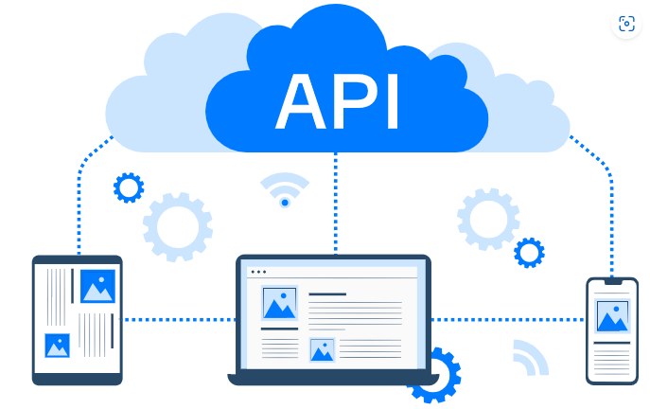

So, there are several API usage types. API may be included in:

* **Libraries.**A library is a set of ready-made codes to be reused during development, and its API is the method by which these running codes interact with each other. An API may consist of several libraries.
* **Frameworks.**A framework can be based on multiple libraries that implement multiple APIs.
* **Operating systems.** An API can specify the interface between an application and the operating system. Most operating systems provide their APIs to other programs to enable them to work with the file system, render graphics, store data, use network capabilities, play audio, and so on.
* **Web API**. These are interfaces for a web server to interact with the application.
* There are also **remote APIs**. They are needed to manage remote resources, for example, databases with the same functionality regardless of language or platform. One such API is the Java Database Connectivity API, where the Java Remote Method Invocation API uses the Java Remote Method Protocol to allow calls to functions that work remotely but appear to be local to the developer.

Below we will describe the most popular tasks developers solve using APIs.

**Common tasks**

An API can have many different functions, and they all depend on a specific application area. Usually, developers need API when

* **working with documents**. An example API is the Document Object Model (DOM) which lets you experiment with the look of a web page.
* **working with graphic data, video, or audio**. For example, using Canvas and WebGL, one can render 2D and 3D graphics and using the Web Audio API, one can create sounds right in the browser.
* **receiving data from the server**. Using the API, applications with the weather, maps, and currency converters are embedded on the site.
* **reading data from devices**. This is required to work on some applications. For example, to create your own navigator, you need an API that can read the location.
* **storing information for the user**. APIs, like the Web Storage API, provide mechanisms for storing data on the client-side. It is an alternative to cookies with more storage space.

**Conclusion**

To sum up,

* API is an Application Programming Interface that describes the ways of interacting with other programs,
* Using API one can connect to the ready-made software to use it in an application and save the development time, or connect to a system using a third-party service account,
* There are different APIs for libraries and frameworks, operating systems, web servers and web browsers, and also remote APIs to manage remote resources,
* Developers can use APIs for various tasks like working with video and audio, receiving data from the server, reading devices data, and so on.

## API is here

The API can be used in various tasks that are performed when you do your usual actions. Which of these options below will include interactions with the API?

The correct options that involve **interactions with an API** are:

✅ **you drop your geolocation in the messenger**  
✅ **you enter a search term in your browser**  
✅ **you log in to the site using your Google account**

**API abbreviation**

API stands for

Select one option from the list

Application Programming Interface

**API usage types**

Which of these options may use an API?

The correct answer is:

✅ **Web API**  
✅ **Libraries**  
✅ **Frameworks**  
✅ **Operating systems**

### ✅ Explanation:

All of these **can use or provide APIs**:

* **Web API**: A type of API used over the internet (e.g., REST APIs).
* **Libraries**: Expose functions and methods — a classic example of an API.
* **Frameworks**: Offer structured APIs to build applications.
* **Operating Systems**: Provide system-level APIs for file access, networking, etc.

**Interaction with system**

The programmer wants to create an application for the Linux operating system. What does the programmer need in order to do this?

Use Linux API so that the app can interact with the system

**Where is API?**

Which of the following are APIs?

The correct answers are:

✅ **Web Audio Interface**  
✅ **Web Storage Interface**

### ❌ Not APIs:

* **your computer's power button** – It's a hardware component, not an API.
* **a browser window** – It's a user interface element, not an application programming interface.

### ✅ Explanation:

* **Web Audio Interface** and **Web Storage Interface** are both **JavaScript APIs** provided by web browsers to let developers interact with audio and local/session storage, respectively.  
  They are designed **for developers**, matching the definition of an API.

**Geolocation on sites**

From which sources can websites access your PC location?

Hint by

The Geolocation API is a powerful feature of the HTML5 Web API that allows web pages to access a user’s device location.

Browser's built-in geolocation API

**Getting web information**

You want to collect text data from Hyperskill. For this, you start writing a special parsing program. But, you notice that Hyperskill has open API access. How can you use this in your code?

The correct answer is:

✅ **Request Hyperskill API to collect texts**

### ✅ Explanation:

If Hyperskill provides an **open API**, you should **make requests to the API** from your code to collect the data programmatically. This is **more efficient and reliable** than parsing HTML or copying manually.

### ❌ Incorrect options:

* **Forget about parsing text and just copy them manually** – Not scalable or efficient.
* **Download Hyperskill API and implement it in your code** – APIs are accessed, not downloaded.
* **Copy Hyperskill API for your code** – Misunderstands how APIs work; you use them via requests, not copy them.

**What does API serve for?**

API describes

the ways for interaction with other programs

**API usage**

For what tasks should a developer use different APIs?

storing data in a web browser

getting the user location for a navigator app

tuning a web page look

creating sounds right in the browser

## Why do we need API?

Select all the true reasons to use API.

API provides tools for working with the software

one can connect systems using API

using API reduces the cost and time of developing a product

API provides data security